1Q.output



2Q.output



3Q.output

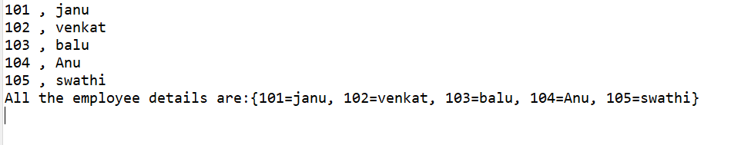

4Q

